ONLINE TICKET BOOKING SYSTEM (FLIGHT) .

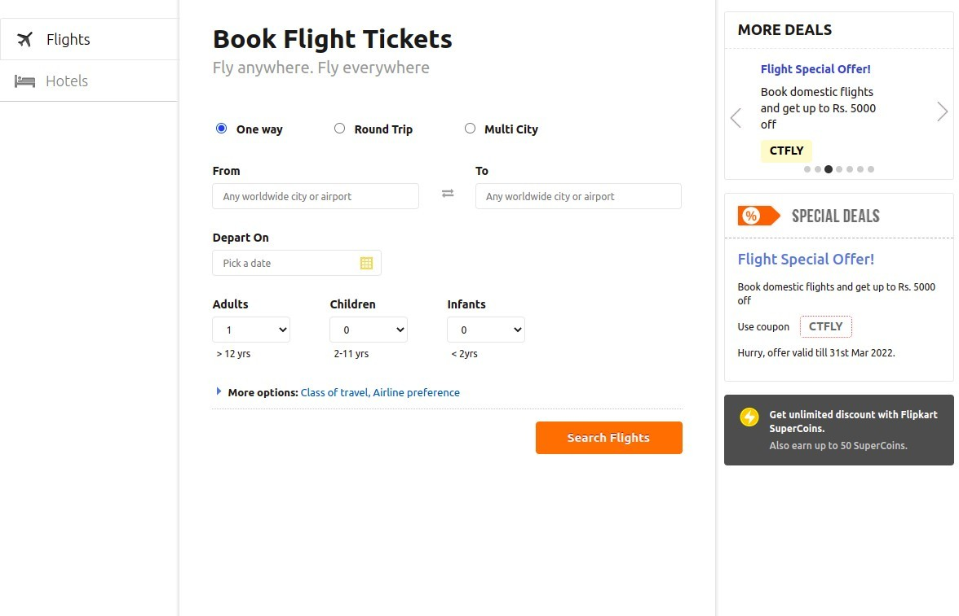

# - NAVEEN MS INTERN AT EDUREKA

**PROJECT OVERVIEW :**

India's Coolest Airline. Best On-time Performance.

Hassle-free Travel. Fly with the Lowest Fares and the Highest Hygiene Standards. Hurry and Book Now! Hassle Free Booking. Multiple Payment Options. Lowest Booking Fee. Amenities: Seat Plus, Excess Baggage.

# Goals :

1.Booking page

-> Bookings

-> Hotels

-> Most Visited Pages

-> Weather update 2.contact page

# Technologies used in Booking system :

Front-end :

1.Html 2.css 3.Bootstrap 4.React

Dynamic:

1.Javascript Database:

1. Mongodb 2.json Data

Code Compilers:

1.VS code 2.Git bash 3.Git hub 4.Node.js